FSDI 106 – Assignment 1
Name: Charles Taggart
Theme: Into Project
GitHub Pages Link: https://github.com/chucktagg83/project106.git
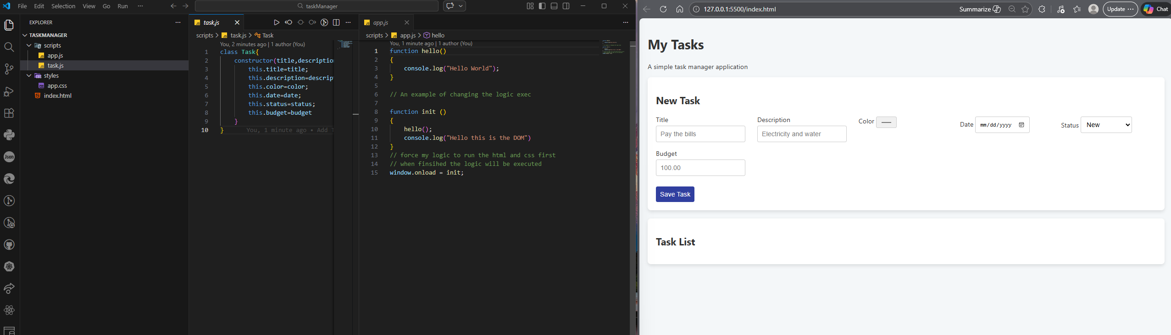

Summary of Edits:
- Created Class to create an object.

